**AutoML Blueprint Quick Start Guide**

Author: Dylan Tong, AWS

The AutoML Blueprint is a no-code, serverless workflow that performs data preparation, automated machine learning model delivery, and validation.

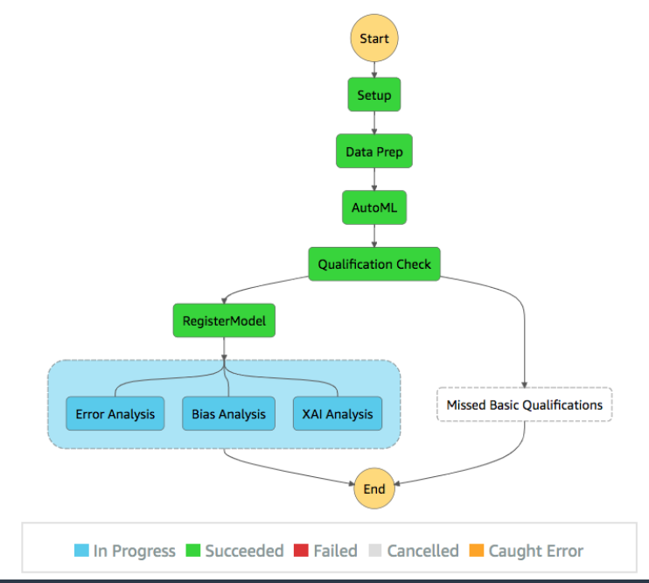

Amazon SageMaker Data Wrangler is used for data preparation. It empowers customers to create no-code data flows. Experimentation and model building are automated using Amazon SageMaker Autopilot, a fully-managed tabular AutoML service.

Predictions are automatically batched to support granular error analysis. Amazon SageMaker Clarify provides bias detection and model explainabilty (XAI). A notebook is packaged along with the solution to guide you through the model inspection process and equip you with tools to help get your consumers to trust your model predictions.

Users deploy this blueprint using CloudFormation to create the AWS StepFunctions workflow above. The user is required to provide the following:

* An Amazon SageMaker DataWrangler flow definition file created through the GUI.
* A dataset for model training and validation.
* Blueprint configurations. The default configurations can be downloaded [here](https://dtong-public-fileshare.s3-us-west-2.amazonaws.com/automl-blueprint/config/blueprint-config.json).

The blueprint delivers an AutoML optimized model along with pre-processed predictions, bias metrics and XAI results that you can use for detailed model inspection.

Quick Launch Steps

1. Launch the CloudFormation template using [this S3 URL](https://dtong-public-fileshare.s3-us-west-2.amazonaws.com/automl-blueprint/code/deploy/cf/automl-blueprint.yml):

<https://dtong-public-fileshare.s3-us-west-2.amazonaws.com/automl-blueprint/code/deploy/cf/automl-blueprint.yml>

Provide a stack name and use the provided *default settings*.

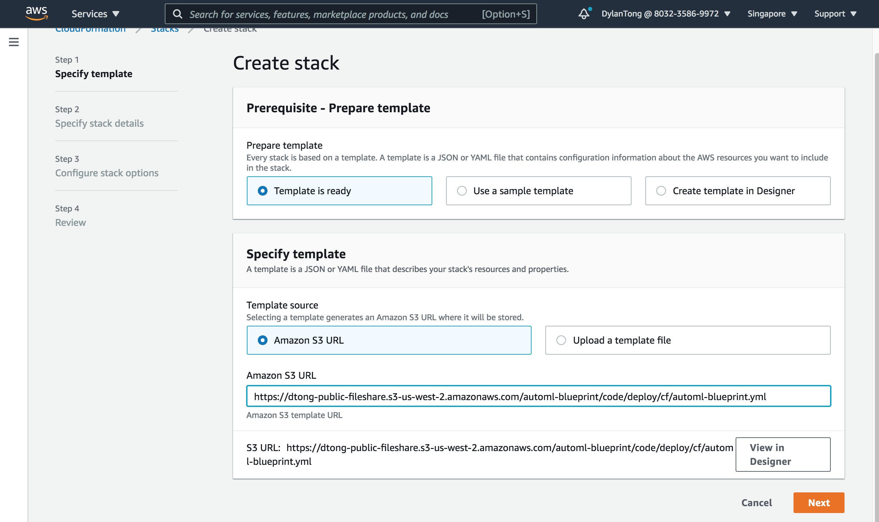

Check the box at the end to acknowledge that this template will create IAM resources.

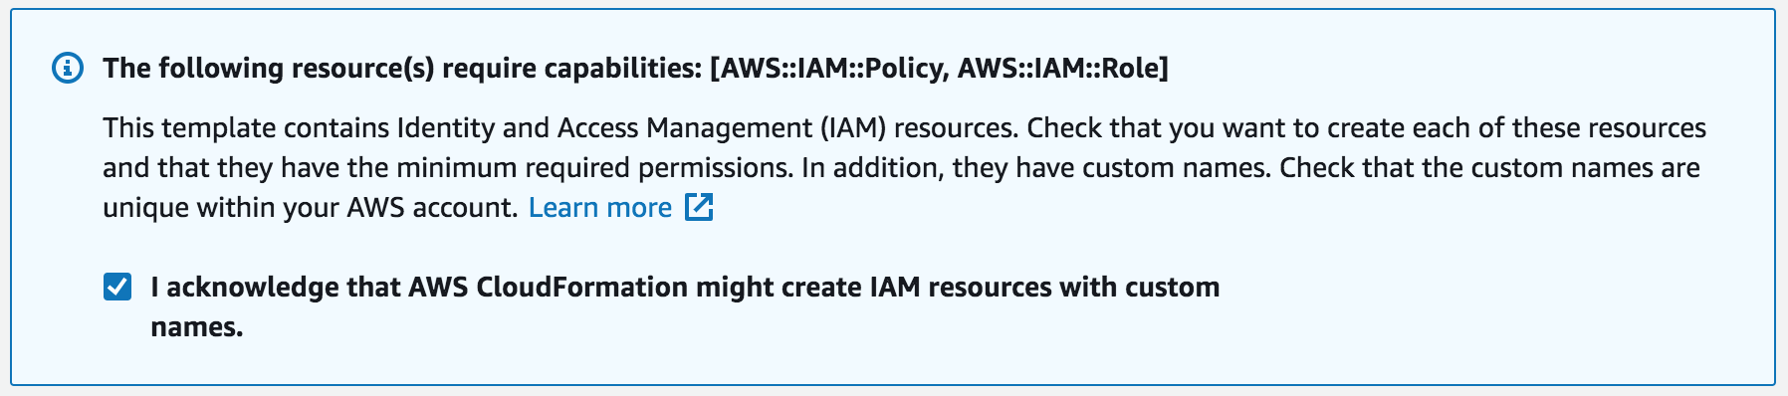

1. Launch Amazon SageMaker Studio if you haven’t done so already. You need to ensure that the IAM role attached to your Studio instance has permissions to run Amazon S3, Amazon SageMaker and AWS StepFunctions.

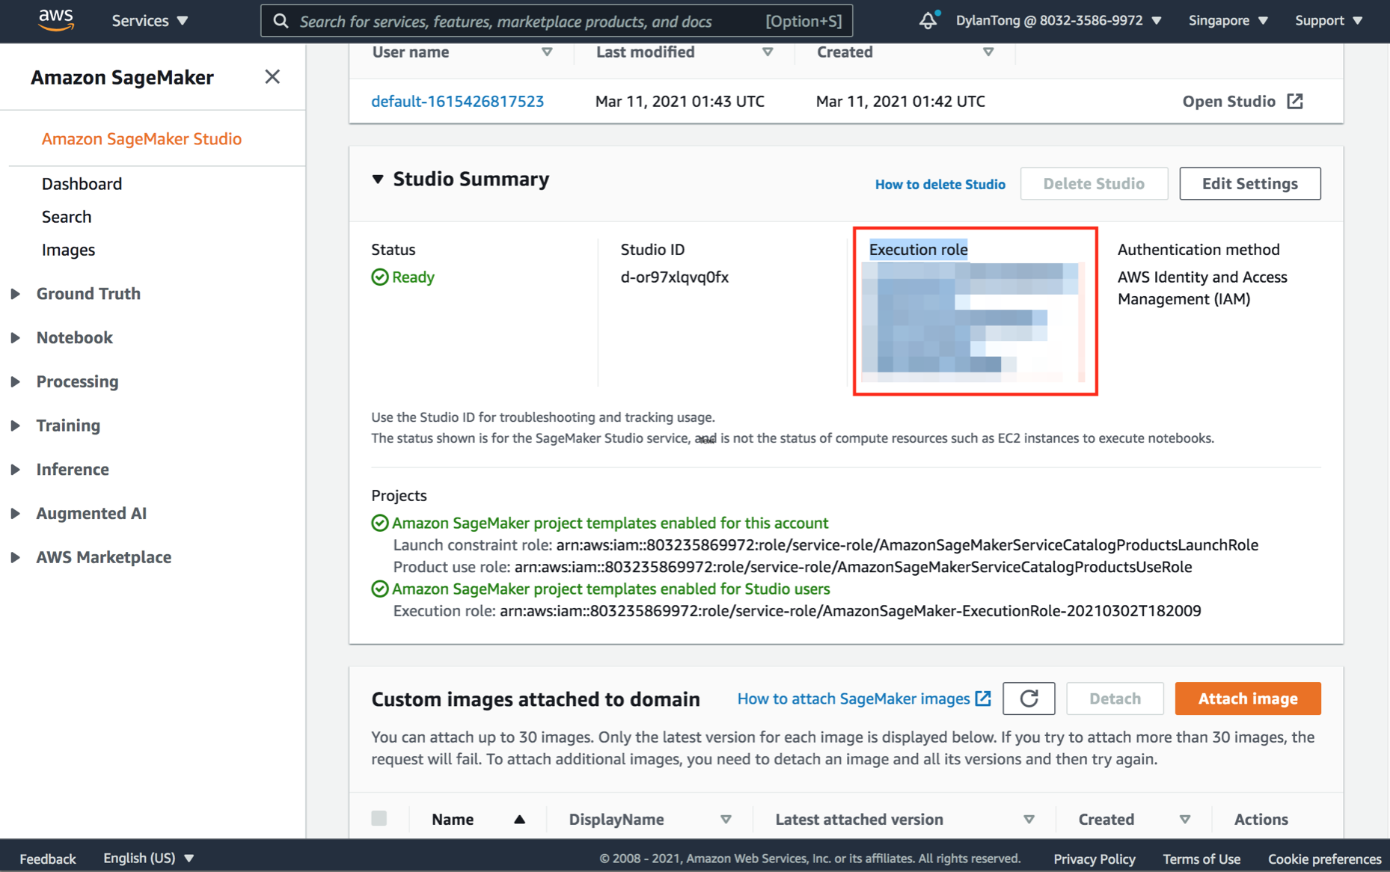

Navigate to the IAM console and attach the following managed policies.

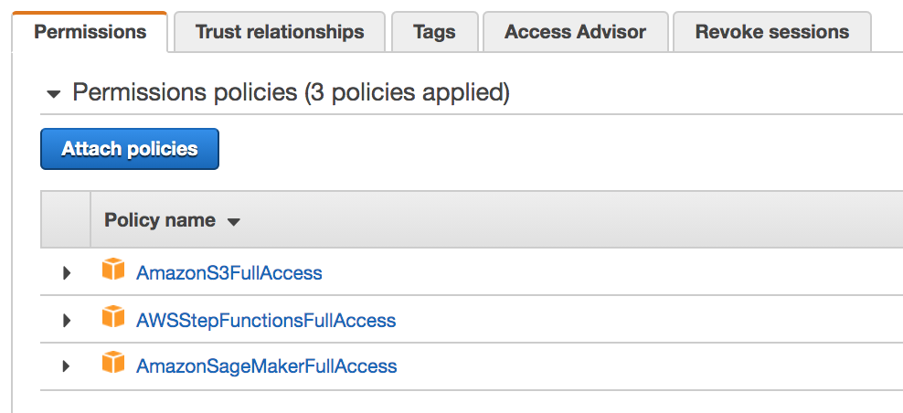

1. Login to Amazon SageMaker Studio. Clone the following Github [repository](https://github.com/aws-samples/automl-blueprint.git): <https://github.com/aws-samples/automl-blueprint.git>



1. Under automl-blueprint/notebook, open the Jupyter notebook user_guide.ipynb. Use the Python3 (Data Science) kernel.

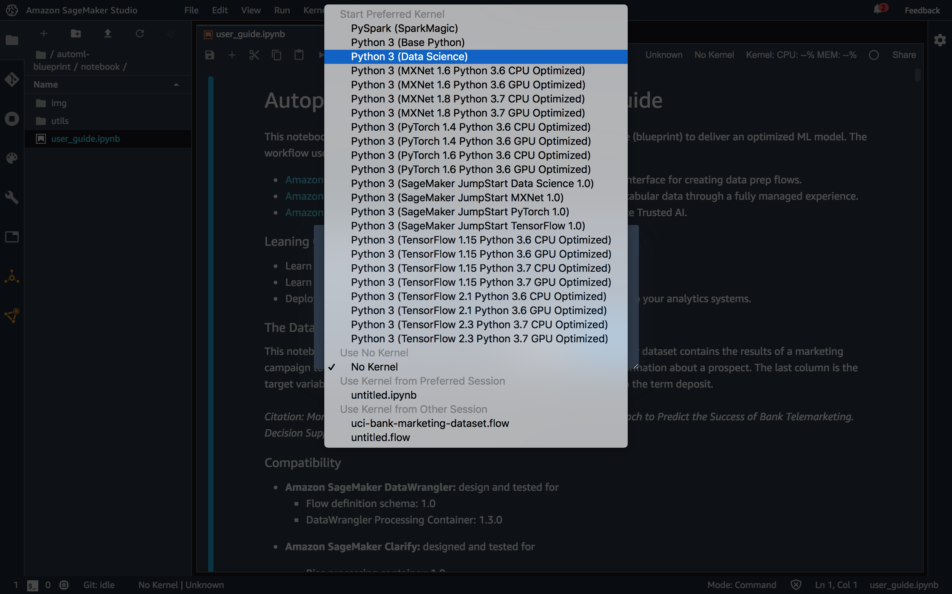

1. Confirm that your CloudFormation template has successfully launched.

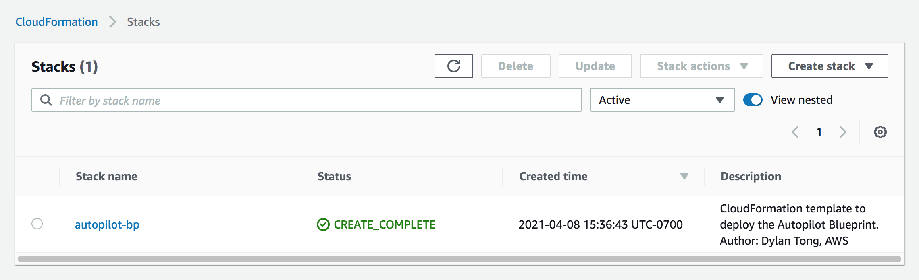

You’re good to go! Follow the steps in the notebook.